**GIT Instructions**

Version control system

Setting up Git

* Run an installer.
* Copy and paste binaries on your $PATH environment variable. Doesn’t need registry entries. Portable more no administrator privileges required.
* Download at <http://git-scm.com>
* Select the Git Bash icon.

Command line environment

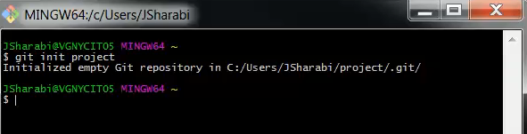

* Enter git init project
* Select Git GUI icon
* Select Open with Sublime Test 2

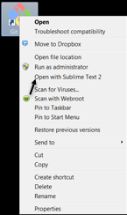

* Enter git status

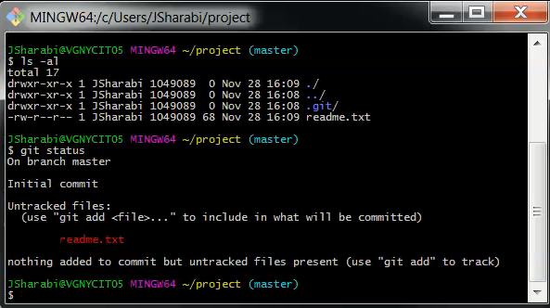

Add file to version control.

* Enter git status
* Enter git add readme.txt
* Enter git commit –m “my first commit

